CT331 Assignment 4

Declarative Programming with Prolog

Andrew Reid East

16280042

C:\Users\deskase\AppData\Local\Microsoft\Windows\INetCache\Content.Word\fa-github-square.png <https://github.com/reideast/ct331_assignment4>

# Question 1

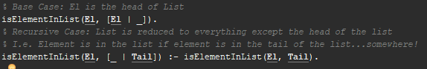

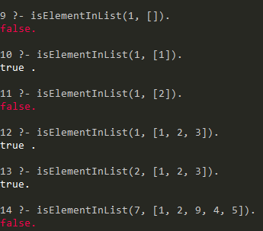

# Question 2

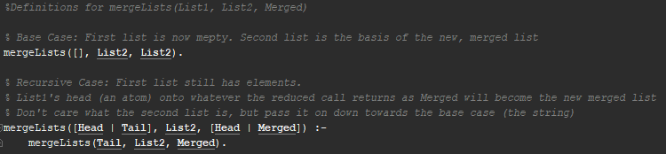

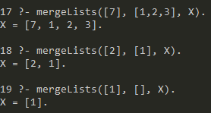

# Question 3

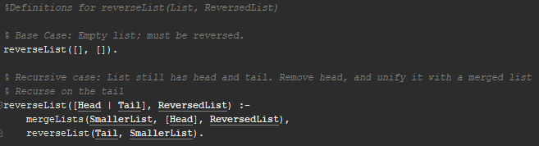

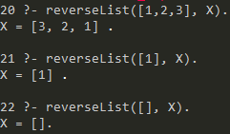

# Question 4

